Web Development 2

The Digital Library

Name: AMIR AKBARI

Student Number: C18442284

Course: DT228/2

Date Due: 6/12/2019

Group A

PHP PAGES

* Reserve page
* This page would Handles all the database relating to reservation for a book.
* searchCategory.php posts ISBN to this page when a user wants to reserve a book. The ISBN is then used to edit the reserved column in the books table, which the ISBN should matches the row of reserved, and then changing the value from ‘N’ to ‘Y’. then the ISBN will insert into the reservedBooks table, which would show us which username and what date they reserved it.
* searchTitle.php works like the searchCategory.php page, posts ISBN number to this page when a user chooses to reserve a book from the list. The ISBN is then used to edit the reserved column in the books table, which the ISBN should matches the row of reserved, and then changing the value from ‘N’ to ‘Y’. then the ISBN will insert into the reservedBooks table, which would show us which username and what date they reserved it.
* Book.php its works like the other two pages above, posts ISBN number to this page when a user chooses to reserve a book from the list. The ISBN is then used to edit the reserved column in the books table, which the ISBN should matches the row of reserved, and then changing the value from ‘N’ to ‘Y’. then the ISBN will insert into the reservedBooks table, which would show us which username and what date they reserved it.
* Also I made an error chacking so If the page is successful and was able to change and insert the new values then ‘confirming reserving the book’ will be displayed, but if there is a problem and the code didn’t execute the following text will be displayed ‘There is a error please try again’.
* db_book.php

This page is used to start a session. It is linked to the pages. And let us connect to the database

* Home.php
  + when a user first attempts to access this page or any of other pages , they won’t be able to see this page if they are not logged in and then they will be redirected to the login page. If the user doesn’t have an account they cant access to this website, then they need to create an account.
  + Contains the nav bar which users can use the other options
  + The logged in details will be displayed at the bottom of the page.
* Login.php
  + displays a form where user is asked to insert their username and password
  + The user’s username and password will be passed into variable which that variable will check against username’s and passwords in the database. If the answer is zero that means the username and password matched and they will logged in to the home.php
  + There is number of error checking in this page for all types of user input. If the user does not fill anything in, or only fills in one the error will be displayed and ask them to fill in all fields. Then next error checking is If no match is found that means they don’t have any account.
  + At the bottom of the page there is link to register, This link will take them to register.php which they can create a new account
* Logout.php
  + When this page is clicked, the username session variable is deleted and session will be destroyed and will be back to the login.php page.
* noReserved.php
  + when the users try to see the Reseved page and they don’t have any book reserved then they will automatically redirect them to this page and this will be displayed ‘You have not reserved any books!’
* register.php
  + A registration will ask user for username, password, confirm password, firstname, surname, address1, address2, city, telephone and mobile fields.
  + The error checking is before the data pass to the database. Which ask user to fill every field and also they can’t have the same username as someone already in database also the confirm password have to be match if not they getting an error.
  + When a user fills in all of the above fields, and there was no error then the details will be added to the database and they can use that account to login.
* RemoveReserved.php
  + This page is for when a user want to remove book, So then the ISBN of that book gets passed to and if the ISBN matches, then it will changing ‘Y’ to ‘N’. also then it will delete the row in the reservedBooks table, then it would be available to other people and other users can reserve this book.
* Book.php
  + Displays all books in that in the database in the order of ‘ISBN’, ‘Title’, ‘Author’, ‘Edition’, ‘Year’, ‘Category’, ‘Reserved’ and also an extra column for the reserve button which allows the user to reserve a book.
  + The page will only show five rows, and if user wants more books have to go to the next page.
* searchCategory.php
  + This page allows the user to search through the database by searching the category.
  + There is an error checking if user enters nothing then the following text will be displayed ‘You must fill in the category box!’. If the search returns no results, ‘No results found, please refine search!’ will be displayed.
  + Displays all books users searched for in the database in the order of ‘ISBN’, ‘Title’, ‘Author’, ‘Edition’, ‘Year’, ‘Category’, ‘Reserved’ and also an extra column for the reserve button which allows the user to reserve a book
  + Also This page will only show five rows, and if user wants more books have to go to the next page.
* searchTitle.php
  + this page will work like the searchCategory, the only difference is this time users would search for the title of a book or the author or both.
  + Displays all books users searched for in the database in the order of ‘ISBN’, ‘Title’, ‘Author’, ‘Edition’, ‘Year’, ‘Category’, ‘Reserved’ and also an extra column for the reserve button which allows the user to reserve a book
  + Also This page will only show five rows, and if user wants more books have to go to the next page.
* viewReserved.php
  1. This page shows all the books that user reserved , if there is no book reserved they will be redirected to noReserved.php
  + If the user reserved any book, the book will display in the order of ‘ISBN’, ‘Title’, ‘Author’, ‘Edition’, ‘Year’, ‘Category’, ‘Reserved’ and also an extra column for the remove button which allows the user to remove a book. Which they will redirect to the removeReserved.php.

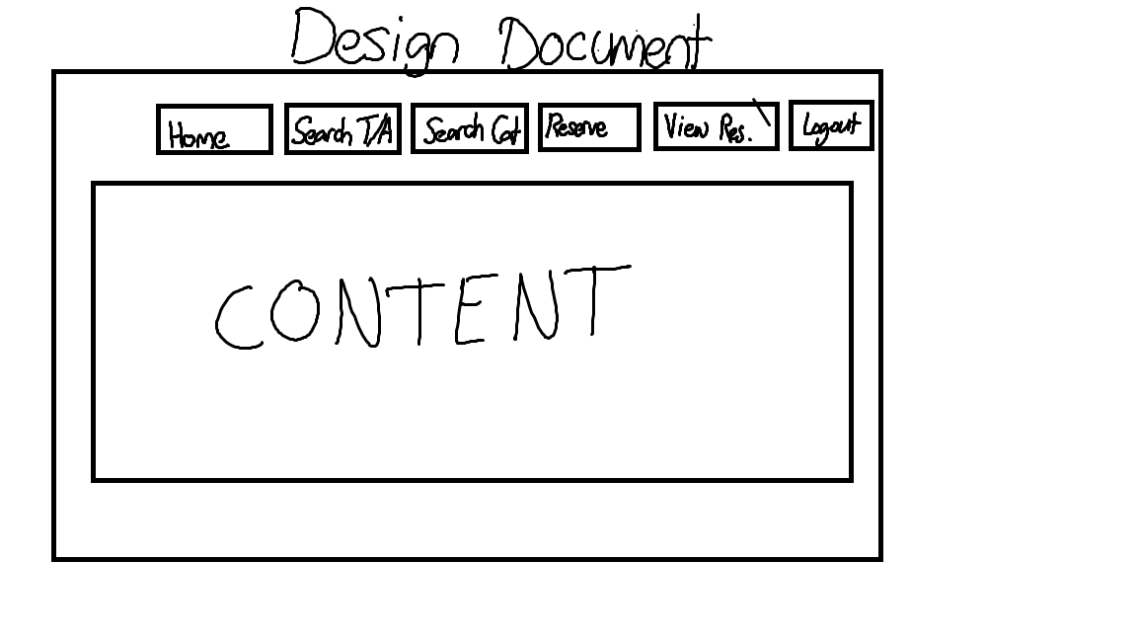Design Document

WebSite ScreenShot

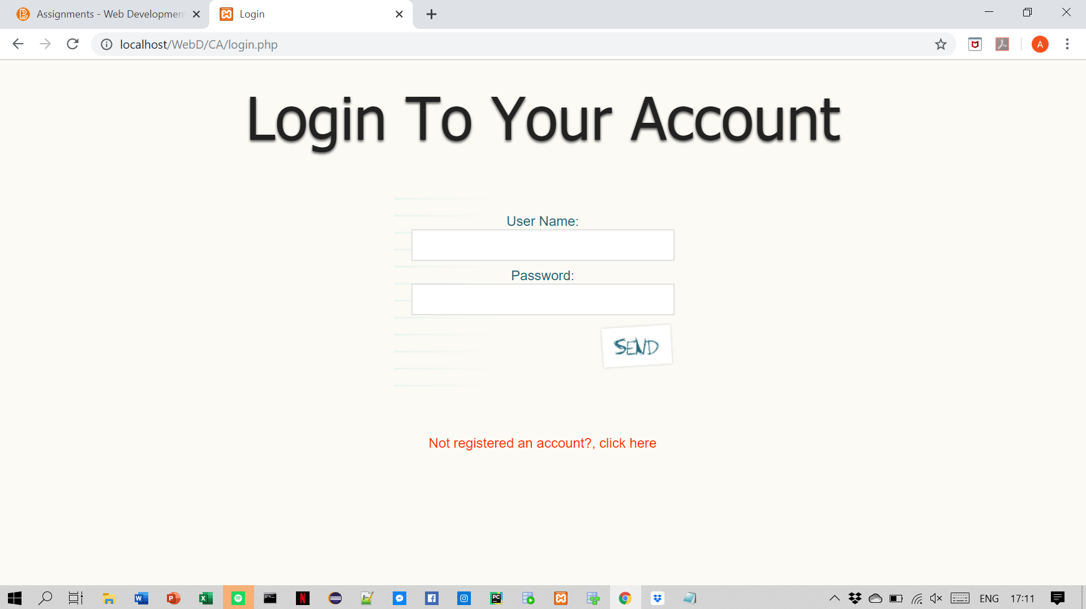

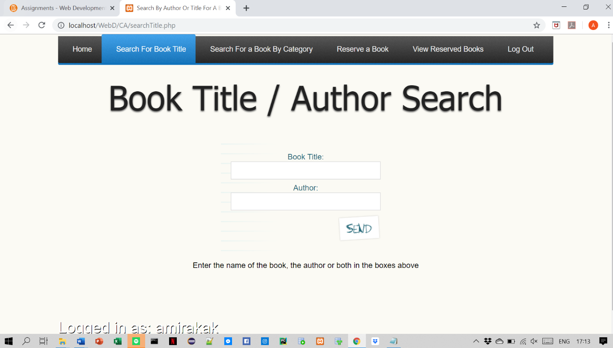

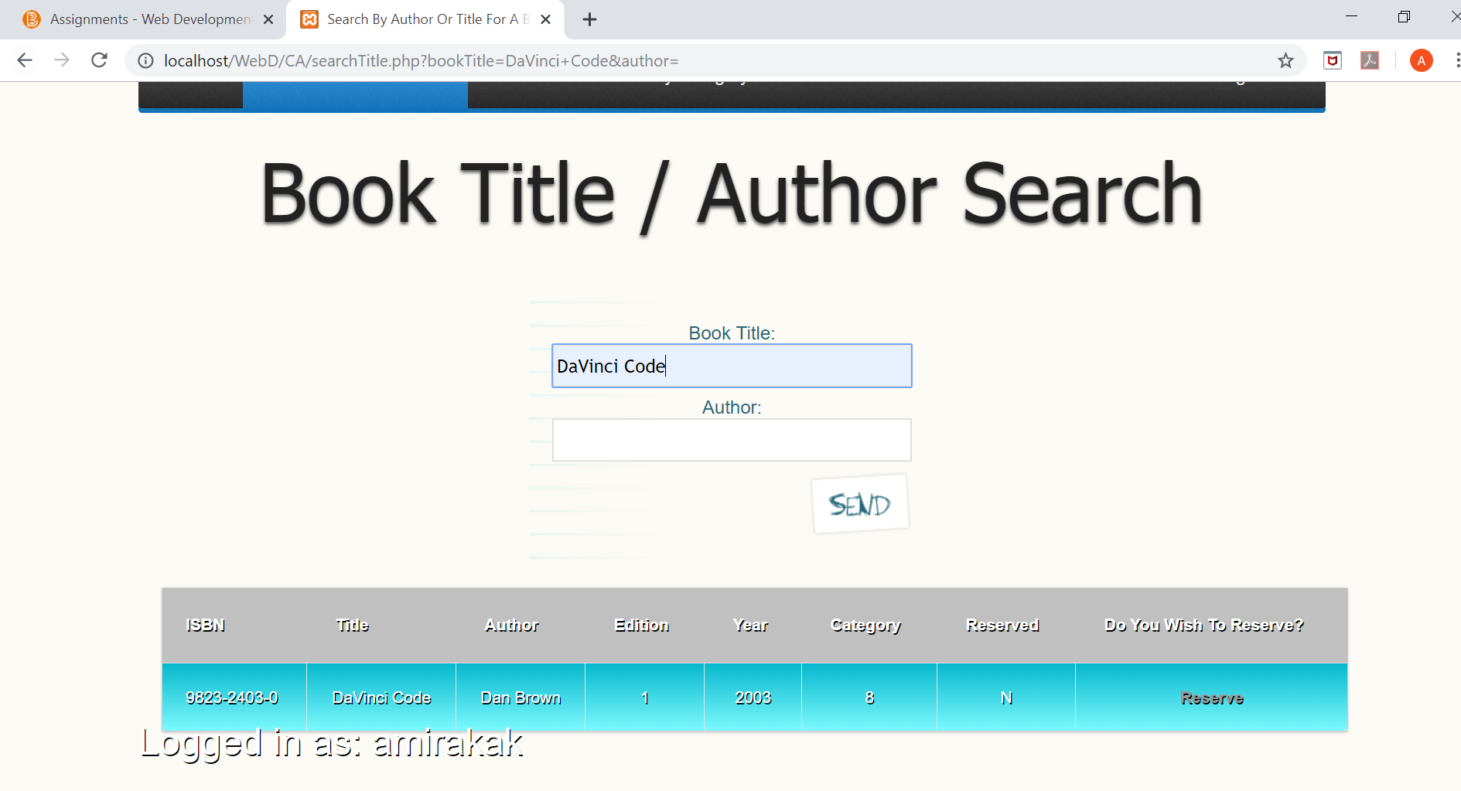

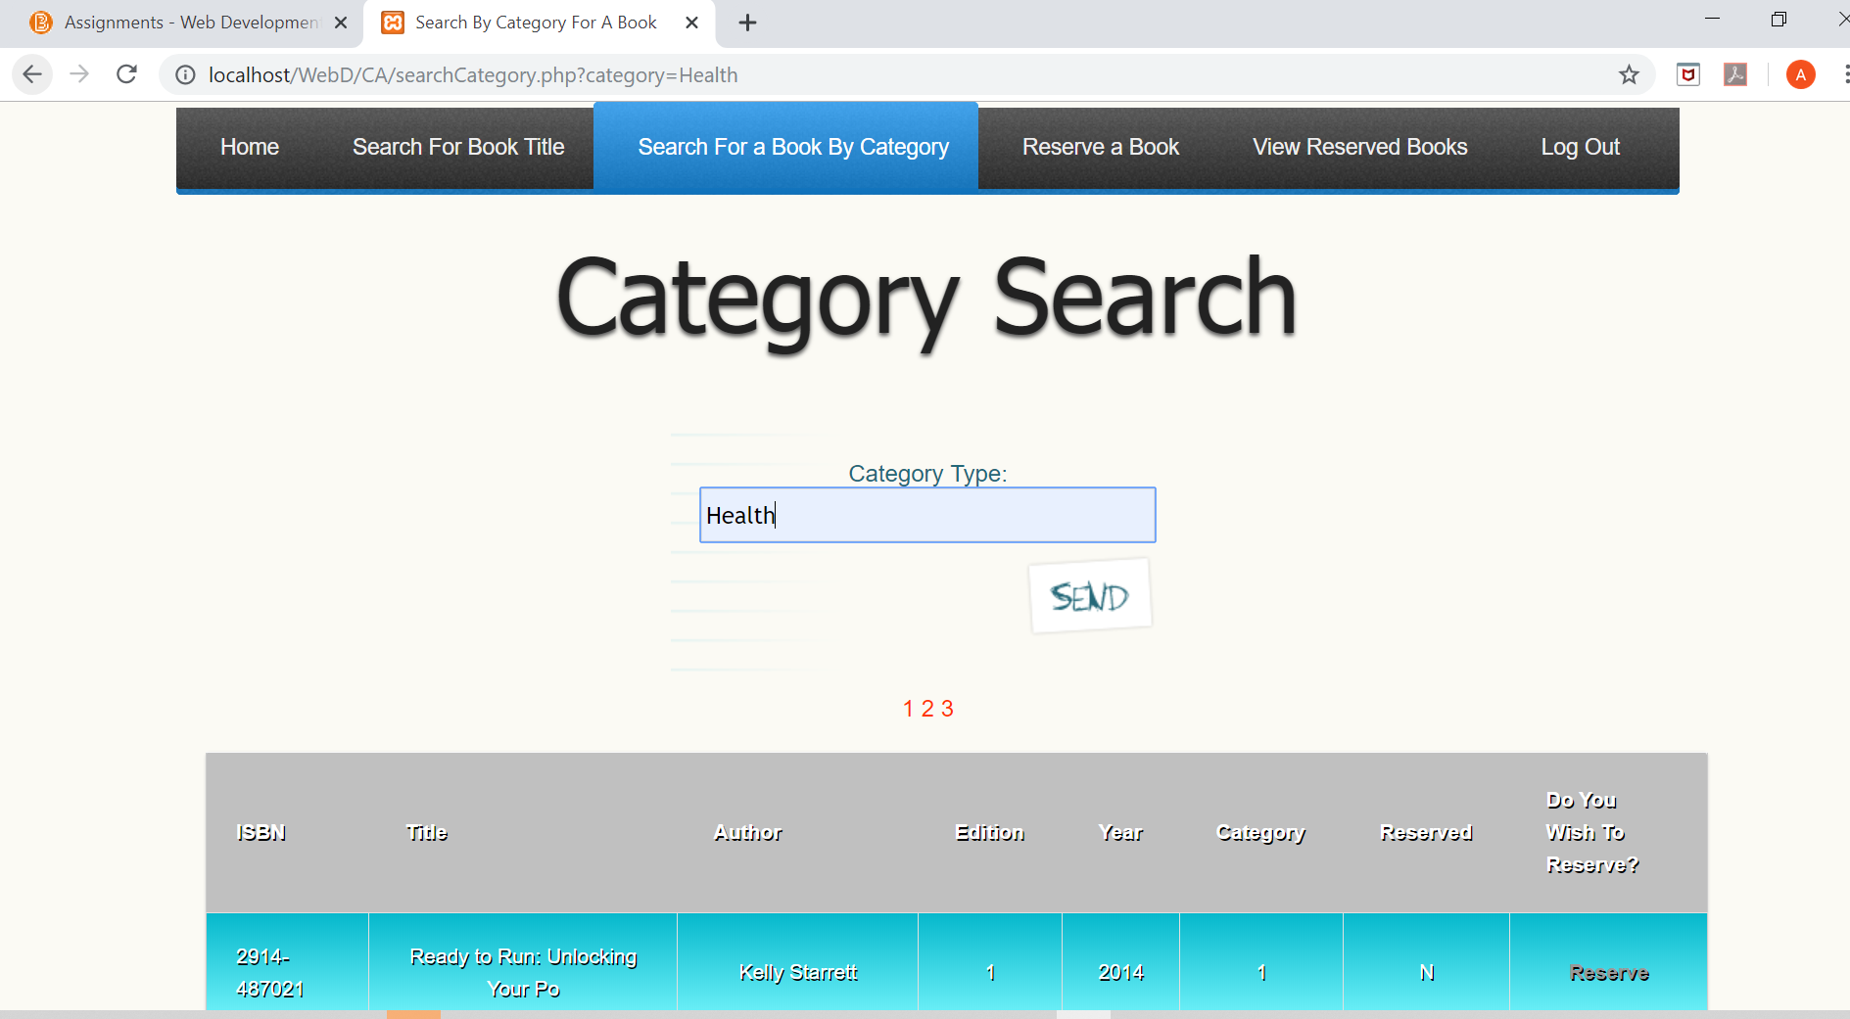

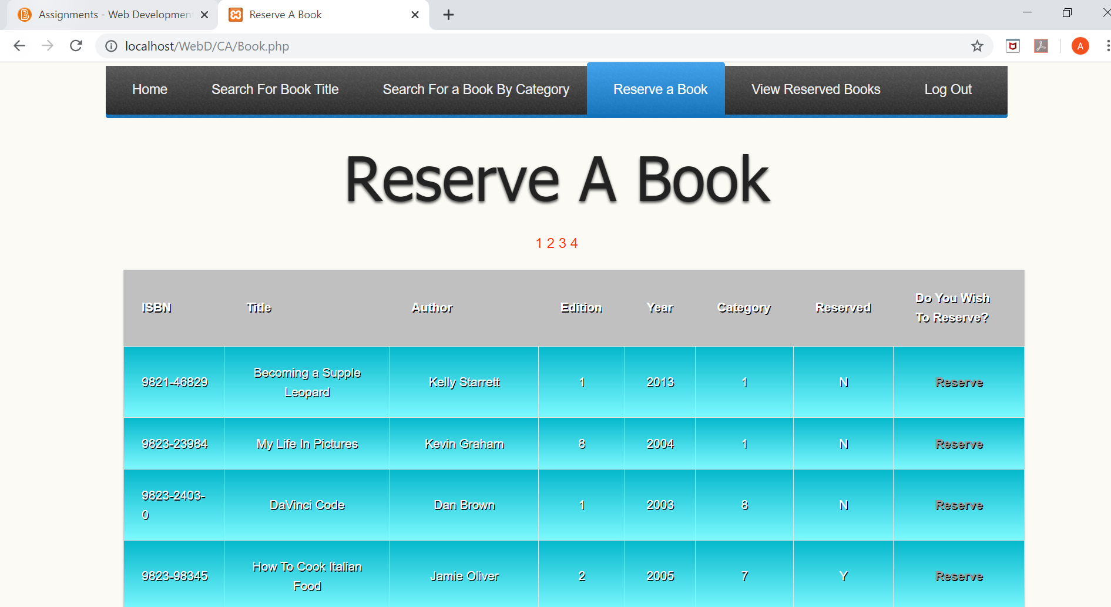

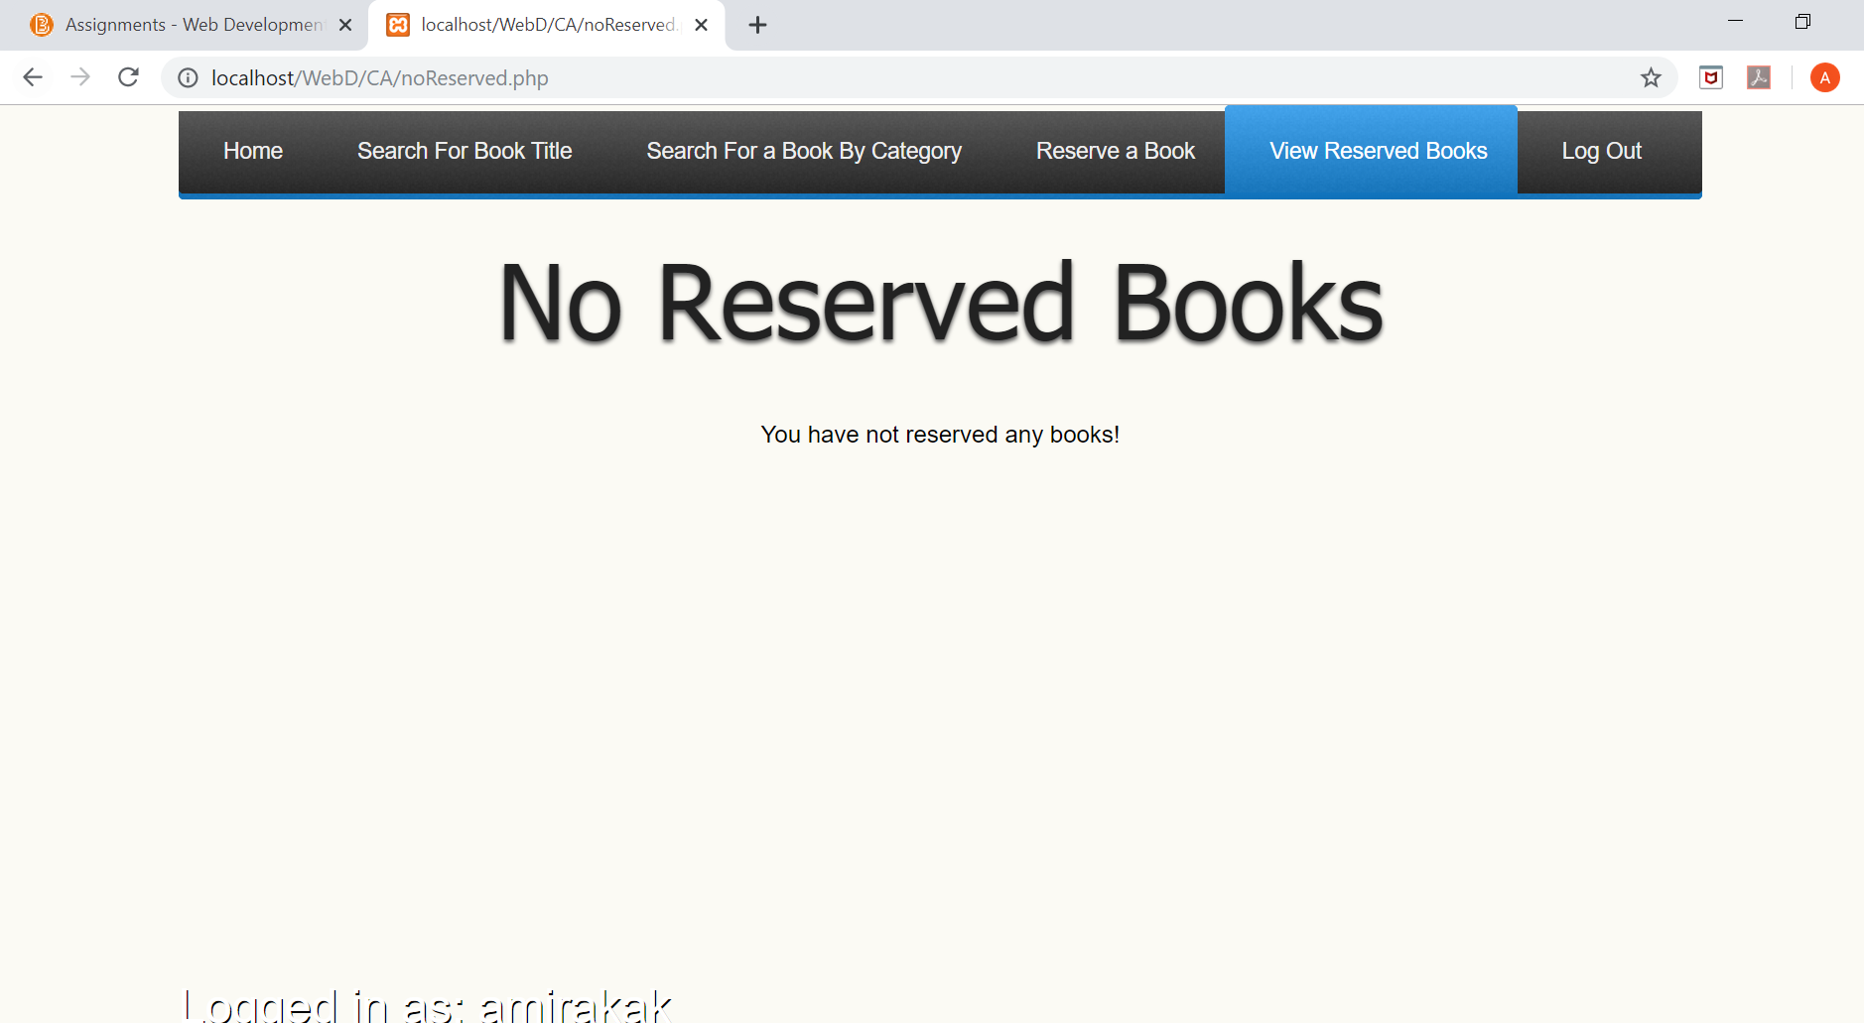

Home.php

<!DOCTYPE html>

<html lang="en">

<head>

<meta charset='utf-8'>

<meta http-equiv="X-UA-Compatible" content="IE=edge">

<meta name="viewport" content="width=device-width, initial-scale=1">

<link rel="stylesheet" href="style.css">

<script src="http://code.jquery.com/jquery-latest.min.js" type="text/javascript"></script>

<script src="script.js"></script>

<title>Home</title>

<link rel="stylesheet" href="style.css">

<?php

session_start();

if(!$_SESSION['userName'])

{

header("location:login.php");

}

?>

</head>

<body>

<div class="body">

<div id='cssmenu'>

<ul>

<li class='active'><a href="Home.php"><span>Home</span></a></li>

<li><a href="searchTitle.php"><span>Search For Book Title</span></a></li>

<li><a href="searchCategory.php"><span>Search For a Book By Category</span></a></li>

<li><a href="Book.php"><span>Reserve a Book</span></a></li>

<li><a href="viewReserved.php"><span>View Reserved Books</span></a></li>

<li class='last'><a href="logout.php"><span>Log Out</span></a></li>

</ul>

</div>

<center>

<h1>Welcome To The Digital Library</h1>

<img src="./images/library-open-book_stock_29062017.jpg" alt="library" style="width:680px;height:340px">

</center></div>

</div>

<?php

echo "<div class=\"footer\">";

echo "<p>Logged in as: " . $_SESSION['userName'] . "</p>";

echo "</div>";

?>

<script src="http://code.jquery.com/jquery-latest.min.js" type="text/javascript"></script>

<script src="script.js"></script>

</body>

</html>

Login.php

<!DOCTYPE html PUBLIC "-//W3C//DD XHTML 1.0 Transitional//EN" "http://www.w3.org/TR/xhtml1/DTD/xhtml1-transitional.dtd">

<html xmlns="http://www.w3.org/1999/xhtml">

<html lang="en">

<head>

<meta charset='utf-8'>

<meta http-equiv="X-UA-Compatible" content="IE=edge">

<meta name="viewport" content="width=device-width, initial-scale=1">

<link rel="stylesheet" href="style.css">

<script src="http://code.jquery.com/jquery-latest.min.js" type="text/javascript"></script>

<script src="script.js"></script>

<title>Login</title>

<?php

session_start();

?>

</head>

<body>

<center>

<h1>Login To Your Account</h1>

<?php

require_once "db_book.php";

echo "<form id=\"form4\" method=\"post\">";

echo "<fieldset><legend>Contact form</legend><p class=\"first\">";

echo "<p class=\"first\">";

echo "<label for=\"userName\">User Name:</label>";

echo "<input type=\"text\" name=\"userName\" maxlength=\"21\" size=\"30\">";

echo "</p>";

echo "<p>";

echo "<label for=\"password\">Password:</label>";

echo "<input type=\"password\" name=\"password\" maxlength=\"6\" size=\"30\">";

echo "</p>";

echo "<p>";

echo "<p class=\"submit\"><button type=\"submit\">Submit</button></p>";

echo "</fieldset>";

echo "</form>";

echo "</tbody>";

$result = mysqli_query($db, "SELECT * FROM users");

if ( isset($_POST['userName']) && isset($_POST['password']))

{

$u = mysqli_real_escape_string( $db, $_POST['userName']);

$p = mysqli_real_escape_string( $db, $_POST['password']);

// To protect MySQL injection

$u = stripslashes($u);

$u = stripslashes($u);

$u = mysqli_real_escape_string($db,$u);

$p = mysqli_real_escape_string($db,$p);

$sql="SELECT * FROM users WHERE userName ='$u' and password ='$p'";

$result=mysqli_query($db,$sql);

// Mysql_num_row is counting table row

$count=mysqli_num_rows($result);

// If result matched $u and $p, table row must be 1 row

if($count==1)

{

// Register $myusername, $mypassword and redirect to file "home.php"

$_SESSION['userName'] = $u;

$_SESSION['password'] = $p;

header("Location:Home.php");

}

else

{

echo "Wrong Username or Password";

}

}

ob_end_flush();

?>

<br>

<br>

<a href="register.php">Not registered an account?, click here</a>

</center>

</body>

</html>

Register.php

<!DOCTYPE html PUBLIC "-//W3C//DD XHTML 1.0 Transitional//EN" "http://www.w3.org/TR/xhtml1/DTD/xhtml1-transitional.dtd">

<html xmlns="http://www.w3.org/1999/xhtml">

<html lang="en">

<head>

<meta charset='utf-8'>

<meta http-equiv="imagetoolbar" content="no" />

<meta name="viewport" content="width=device-width, initial-scale=1">

<link rel="stylesheet" href="style.css">

<script src="http://code.jquery.com/jquery-latest.min.js" type="text/javascript"></script>

<script src="script.js"></script>

<title>Create An Account</title>

</head>

<body>

<center>

<h1>Create an account</h1>

<?php

require_once "db_book.php";

$result = mysqli_query($db,"SELECT * FROM users");

if ( isset($_POST['userName']) && isset($_POST['password']) && isset($_POST['firstName']) && isset($_POST['surName']) && isset($_POST['addressLine1']) && isset($_POST['addressLine2']) && isset($_POST['city']) && isset($_POST['telephone']) && isset($_POST['mobile']))

{

$check = True;

$u = trim(mysqli_real_escape_string($db,$_POST['userName']));

$p = trim(mysqli_real_escape_string($db,$_POST['password']));

$pc = trim(mysqli_real_escape_string($db,$_POST['passwordConfirm']));

$n = trim(mysqli_real_escape_string($db,$_POST['firstName']));

$sn = trim(mysqli_real_escape_string($db,$_POST['surName']));

$a1 = trim(mysqli_real_escape_string($db,$_POST['addressLine1']));

$a2 = trim(mysqli_real_escape_string($db,$_POST['addressLine2']));

$c = trim(mysqli_real_escape_string($db,$_POST['city']));

$t = trim(mysqli_real_escape_string($db,$_POST['telephone']));

$m = trim(mysqli_real_escape_string($db,$_POST['mobile']));

if ($p === $pc)

{

while ( $row = mysqli_fetch_row($result) )

{

if ($row[0] == $u)

{

$check = False;

echo "That User Name has been taken, please use another User Name";

}

else if ($u == '' || $p == '' || $n == '' || $sn == '' || $a1 == '' || $a2 == '' || $c == '' || $t == '' || $m == '')

{

$check = False;

echo "Please fill in all fields!";

break;

}

}

if($check == true)

{

$sql = "INSERT INTO users (userName, password, firstName, surName, addressLine1, addressLine2, city, telephone, mobile) VALUES ('$u', '$p', '$n', '$sn', '$a1', '$a2', '$c', '$t', '$m')";

mysqli_query($db, $sql);

echo "Successfully added user: " . $u;

header("location:Home.php");

}

}

else

{

echo "The passwords you entered do not match";

}

}

else

{

echo "Please fill in your details to create your account";

}

?>

<?php

echo "<form id=\"form4\" method=\"post\">";

echo "<fieldset><legend>Contact form</legend><p class=\"first\">";

echo "<p class=\"first\">";

echo "<label for=\"userName\">User Name:</label>";

echo "<input type=\"text\" name=\"userName\" id=\"userName\" maxlength=\"21\" size=\"30\">";

echo "</p>";

echo "<p>";

echo "<label for=\"password\">Password:</label>";

echo "<input type=\"password\" name=\"password\" id=\"password\" maxlength=\"6\" size=\"30\">";

echo "</p>";

echo "<p>";

echo "<label for=\"passwordConfirm\">Confirm Password:</label>";

echo "<input type=\"password\" name=\"passwordConfirm\" id=\"passwordConfirm\" maxlength=\"6\" size=\"30\">";

echo "</p>";

echo "<p>";

echo "<label for=\"firstName\">First Name:</label>";

echo "<input type=\"text\" name=\"firstName\" id=\"firstName\" maxlength=\"11\" size=\"30\">";

echo "</p>";

echo "<p>";

echo "<label for=\"surName:\">SurName:</label>";

echo "<input type=\"text\" name=\"surName\" id=\"surName\" maxlength=\"21\" size=\"30\">";

echo "</p>";

echo "<p>";

echo "<label for=\"addressLine1\">AddressLine 1:</label>";

echo "<input type=\"text\" name=\"addressLine1\" id=\"addressLine1\" maxlength=\"21\" size=\"30\">";

echo "</p>";

echo "<p>";

echo "<label for=\"addressLine2\">Address Line 2:</label>";

echo "<input type=\"text\" name=\"addressLine2\" id=\"addressLine2\" maxlength=\"21\" size=\"30\">";

echo "</p>";

echo "<p>";

echo "<label for=\"city\">City:</label>";

echo "<input type=\"text\" name=\"city\" id=\"city\" maxlength=\"11\" size=\"30\">";

echo "</p>";

echo "<p>";

echo "<label for=\"telephone\">Telephone:</label>";

echo "<input type=\"number\" name=\"telephone\" id=\"telephone\" maxlength=\"10\" size=\"30\">";

echo "<label for=\"mobile\">Mobile:</label>";

echo "<input type=\"number\" name=\"mobile\" id=\"number\" maxlength=\"10\ size=\"30\">";

echo "</p>";

echo "<p>";

echo "<p class=\"submit\"><button type=\"submit\">Add New</button></p>";

echo "</fieldset>";

echo "</form>";

?>

<br>

<br>

<a href="Home.php">Return To Home</a>

</center>

<script src="http://www.google-analytics.com/urchin.js" type="text/javascript">

</script>

<script src="http://code.jquery.com/jquery-latest.min.js" type="text/javascript"></script>

<script src="script.js"></script>

<script type="text/javascript">

_uacct = "UA-783567-1";

urchinTracker();

</script>

</body>

</html>

Seachtitle.php

<!DOCTYPE html PUBLIC "-//W3C//DD XHTML 1.0 Transitional//EN" "http://www.w3.org/TR/xhtml1/DTD/xhtml1-transitional.dtd">

<html xmlns="http://www.w3.org/1999/xhtml">

<html lang="en">

<head>

<meta charset='utf-8'>

<meta http-equiv="X-UA-Compatible" content="IE=edge">

<meta name="viewport" content="width=device-width, initial-scale=1">

<link rel="stylesheet" href="style.css">

<script src="http://code.jquery.com/jquery-latest.min.js" type="text/javascript"></script>

<script src="script.js"></script>

<title>Search By Author Or Title For A Book</title>

<?php

session_start();

if(!$_SESSION['userName'])

{

header("location:login.php");

}

?>

</head>

<body>

<div class="wrapper">

<div id='cssmenu'>

<ul>

<li><a href="Home.php"><span>Home</span></a></li>

<li class='active'><a href="searchTitle.php"><span>Search For Book Title</span></a></li>

<li><a href="searchCategory.php"><span>Search For a Book By Category</span></a></li>

<li><a href="Book.php"><span>Reserve a Book</span></a></li>

<li><a href="viewReserved.php"><span>View Reserved Books</span></a></li>

<li class='last'><a href="logout.php"><span>Log Out</span></a></li>

</ul>

</div>

<center>

<h1>Book Title / Author Search</h1>

<form id="form4" method="get">

<fieldset><legend>Search form</legend><p class="first">

<p class="first">

<label for="bookTitle">Book Title:</label>

<input type="text" name="bookTitle" maxlength="31" size="30">

</p>

<p>

<label for="author">Author:</label>

<input type="text" name="author" maxlength="31" size="30">

</p>

<p>

<p class="submit"><button type="submit" value="Search">Search</button></p>

</fieldset>

</form>

<?php

require_once "db_book.php";

if ( isset($_GET['bookTitle']) && isset($_GET['author']))

{

$t = mysqli_real_escape_string($db, $_GET['bookTitle']);

$a = mysqli_real_escape_string($db, $_GET['author']);

if (trim($t) != '' || trim($a) != '')

{

if (trim($a) == '')

{

search($t, NULL, 1);

}

else if (trim($t) == '')

{

search($a, NULL, 2);

}

else

{

search($t, $a, 3);

}

}

else

{

echo "You must fill in at least one of the fields!";

}

}

else

{

echo "Enter the name of the book, the author or both in the boxes above";

}

function search($searchTerm1, $searchTerm2, $option)

{

global $db;

if ($option == 1)

{

$sql = ("SELECT * FROM books WHERE bookTitle LIKE '%$searchTerm1%'");

}

else if ($option == 2)

{

$sql = ("SELECT * FROM books WHERE author LIKE '%$searchTerm1%'");

}

else

{

$sql = ("SELECT * FROM books WHERE bookTitle LIKE '%$searchTerm1%' AND author LIKE '%$searchTerm2%'");

}

$result = mysqli_query($db, $sql);

if(mysqli_num_rows($result) === 0)

{

echo "No results found, please refine search!";

die(mysqli_error());

}

echo "</p>";

echo "<table cellspacing='0'>";

echo "<form action= \"autoReserve.php\" method='post'>";

echo "<thead>";

echo"<tr><th>"; echo "ISBN";

echo"</th><th>"; echo "Title";

echo"</th><th>"; echo "Author";

echo "</th><th>"; echo "Edition";

echo "</th><th>"; echo "Year";

echo "</th><th>"; echo "Category";

echo "</th><th>"; echo "Reserved";

echo "</th><th>"; echo "Do You Wish To Reserve?";

echo "</th></tr>";

echo"</thead>";

echo "<tbody>";

// loop through results of database query, displaying them in the table

for ($i = 0; $i < mysqli_num_rows($result); $i++)

{

while ( $row = mysqli_fetch_row($result) ) {

echo("<tr><td>");

echo($row[0]);

echo("</td><td>");

echo($row[1]);

echo("</td><td>");

echo($row[2]);

echo("</td><td>");

echo($row[3]);

echo("</td><td>");

echo($row[4]);

echo("</td><td>");

echo($row[5]);

echo("</td><td>");

echo($row[6]);

echo("</td><td>");

echo('<a href="autoReserve.php?ISBN='.htmlentities($row[0]).'">Reserve</a> ');

echo("</tdr>\n");

echo "</tbody>";

echo "</form>";

echo "</table>";

if (($i % 2) == 0)

{

echo"<tr class =\"even\"><td>";

}

else

{

echo"<tr><td>";

}

}

}

}

?>

</center>

</div>

</div>

<?php

echo "<div class=\"footer\">";

echo "<p>Logged in as: " . $_SESSION['userName'] . "</p>";

echo "</div>";

?>

</body>

</html>

searchCategory.php

<!DOCTYPE html PUBLIC "-//W3C//DD XHTML 1.0 Transitional//EN" "http://www.w3.org/TR/xhtml1/DTD/xhtml1-transitional.dtd">

<html xmlns="http://www.w3.org/1999/xhtml">

<html lang="en">

<head>

<meta charset='utf-8'>

<meta http-equiv="X-UA-Compatible" content="IE=edge">

<meta name="viewport" content="width=device-width, initial-scale=1">

<link rel="stylesheet" href="style.css">

<script src="http://code.jquery.com/jquery-latest.min.js" type="text/javascript"></script>

<script src="script.js"></script>

<title>Search By Category For A Book</title>

<?php

session_start();

if(!$_SESSION['userName'])

{

header("location:login.php");

}

?>

</head>

<body>

<div class="wrapper">

<div id='cssmenu'>

<ul>

<li><a href="Home.php"><span>Home</span></a></li>

<li><a href="searchTitle.php"><span>Search For Book Title</span></a></li>

<li class='active'><a href="searchCategory.php"><span>Search For a Book By Category</span></a></li>

<li><a href="Book.php"><span>Reserve a Book</span></a></li>

<li><a href="viewReserved.php"><span>View Reserved Books</span></a></li>

<li class='last'><a href="logout.php"><span>Log Out</span></a></li>

</ul>

</div>

<center>

<h1>Category Search</h1>

<form id="form4" method="get">

<fieldset><legend>Search form</legend><p class="first">

<p class="first">

<label for="category">Category Type:</label>

<input type="text" name="category" maxlength="31" size="30"></p>

<p>

<p class="submit"><button type="submit" value="Search">Search</button></p>

</fieldset></form>

<?php

require_once "db_book.php";

if ( isset($_GET['category']))

{

$c = $_GET['category'];

if (trim($c) != '')

{

$sql = ("SELECT * FROM books LEFT JOIN categories ON books.category = categories.categoryID WHERE CategoryDescription LIKE '%".$c."%'");

$result = mysqli_query($db,$sql);

if(mysqli_num_rows($result) === 0)

{

echo "No results found, please refine search!";

die(mysqli_error($db));

}

$row = mysqli_fetch_assoc($result);

// number of results to show per page

$per_page = 5;

// figure out the total pages in the database

$total_results = mysqli_num_rows($result);

$total_pages = ceil($total_results / $per_page);

// check if the 'page' variable is set in the URL

if (isset($_GET['page']) && is_numeric($_GET['page']))

{

$show_page = $_GET['page'];

// make sure the $show_page value is valid

if ($show_page > 0 && $show_page <= $total_pages)

{

$start = ($show_page -1) * $per_page;

$end = $start + $per_page;

}

else

{

// error - show first set of results

$start = 0;

$end = $per_page;

}

}

else

{

// if page isn't set, show first set of results

$start = 0;

$end = $per_page;

}

// display pagination

for ($i = 1; $i <= $total_pages; $i++)

{

echo "<a href='searchCategory.php?&category=$c&page=$i'>$i</a> ";

}

echo "</p>";

echo "<table cellspacing='0'>";

echo "<form action= \"autoReserve.php\" method='post'>";

echo "<thead>";

echo"<tr><th>"; echo "ISBN";

echo"</th><th>"; echo "Title";

echo"</th><th>"; echo "Author";

echo "</th><th>"; echo "Edition";

echo "</th><th>"; echo "Year";

echo "</th><th>"; echo "Category";

echo "</th><th>"; echo "Reserved";

echo "</th><th>"; echo "Do You Wish To Reserve?";

echo "</th></tr>";

echo "</thead>";

echo "<tbody>";

for ($i = $start; $i < $end; $i++)

{

// make sure that PHP doesn't try to show results that don't exist

if ($i == $total_results)

{

break;

}

while ( $row = mysqli_fetch_row($result) ) {

echo("<tr><td>");

echo($row[0]);

echo("</td><td>");

echo($row[1]);

echo("</td><td>");

echo($row[2]);

echo("</td><td>");

echo($row[3]);

echo("</td><td>");

echo($row[4]);

echo("</td><td>");

echo($row[5]);

echo("</td><td>");

echo($row[6]);

echo("</td><td>");

echo('<a href="autoReserve.php?ISBN='.htmlentities($row[0]).'">Reserve</a> ');

echo("</tdr>\n");

}

echo "</tbody>";

echo "</form>";

echo "</table>";

}

}

}

else

{

echo "You must fill in the category box!";

}

?>

</center>

</div>

</div>

<?php

echo "<div class=\"footer\">";

echo "<p>Logged in as: " . $_SESSION['userName'] . "</p>";

echo "</div>";

?>

<script src="http://code.jquery.com/jquery-latest.min.js" type="text/javascript"></script>

<script src="script.js"></script>

</body>

</html>

Autoreserv.php

<!DOCTYPE html PUBLIC "-//W3C//DD XHTML 1.0 Transitional//EN" "http://www.w3.org/TR/xhtml1/DTD/xhtml1-transitional.dtd">

<html xmlns="http://www.w3.org/1999/xhtml">

<html lang="en">

<head>

<meta charset='utf-8'>

<meta http-equiv="X-UA-Compatible" content="IE=edge">

<meta name="viewport" content="width=device-width, initial-scale=1">

<link rel="stylesheet" href="style.css">

<script src="http://code.jquery.com/jquery-latest.min.js" type="text/javascript"></script>

<script src="script.js"></script>

<title>Reserving Book</title>

<?php

session_start();

if(!$_SESSION['userName'])

{

header("location:login.php");

}

?>

</head>

<body>

<div class="wrapper">

<div id='cssmenu'>

<ul>

<li><a href="Home.php"><span>Home</span></a></li>

<li><a href="searchTitle.php"><span>Search For Book Title</span></a></li>

<li><a href="searchCategory.php"><span>Search For a Book By Category</span></a></li>

<li class='active'><a href="Book.php"><span>Reserve a Book</span></a></li>

<li><a href="viewReserved.php"><span>View Reserved Books</span></a></li>

<li class='last'><a href="logout.php"><span>Log Out</span></a></li>

</ul>

</div>

<center>

<?php

require_once "db_book.php";

if(isset($_GET['ISBN'])){

$ISBN = mysqli_real_escape_string($db, $_GET['ISBN']);

$sql= mysqli_query("INSERT INTO reservedbooks (ISBN, userName, reservedDate) VALUES ('$ISBN','".$_SESSION['userName']."', '".date("d/m/Y")."')");

mysqli_query($db, $sql);

$sql ="UPDATE books SET reserved = 'Y' WHERE ISBN = '".$ISBN."'";

if (!mysql_query($sql))

{

echo $sql;

echo "<h1>There was an error when processing the request</h1>";

}

else

{

$result = mysql_query($sql);

echo "<h1>Book Successfully Reserved</h1>";

}

}

?>

<a href="Home.php">Return to Home</a>

</center>

</div>

</div>

<?php

echo "<div class=\"footer\">";

echo "<p>Logged in as: " . $_SESSION['userName'] . "</p>";

echo "</div>";

?>

<script src="http://code.jquery.com/jquery-latest.min.js" type="text/javascript"></script>

<script src="script.js"></script>

</body>

</html>

Book.php

<!DOCTYPE html PUBLIC "-//W3C//DD XHTML 1.0 Transitional//EN" "http://www.w3.org/TR/xhtml1/DTD/xhtml1-transitional.dtd">

<html xmlns="http://www.w3.org/1999/xhtml">

<html lang="en">

<head>

<meta charset='utf-8'>

<meta http-equiv="X-UA-Compatible" content="IE=edge">

<meta name="viewport" content="width=device-width, initial-scale=1">

<link rel="stylesheet" href="style.css">

<script src="http://code.jquery.com/jquery-latest.min.js" type="text/javascript"></script>

<script src="script.js"></script>

<title>Reserve A Book</title>

<?php

session_start();

if(!$_SESSION['userName'])

{

header("location:login.php");

}

?>

</head>

<body>

<div class="wrapper">

<div id='cssmenu'>

<ul>

<li><a href="Home.php"><span>Home</span></a></li>

<li><a href="searchTitle.php"><span>Search For Book Title</span></a></li>

<li><a href="searchCategory.php"><span>Search For a Book By Category</span></a></li>

<li class='active'><a href="Book.php"><span>Reserve a Book</span></a></li>

<li><a href="viewReserved.php"><span>View Reserved Books</span></a></li>

<li class='last'><a href="logout.php"><span>Log Out</span></a></li>

</ul>

</div>

<center>

<h1>Reserve A Book</h1>

<?php

require_once "db_book.php";

$result = mysqli_query($db,"SELECT * FROM books");

$row = mysqli_fetch_array($result);

// number of results to show per page

$per_page = 5;

// figure out the total pages in the database

$total_results = mysqli_num_rows($result);

$total_pages = ceil($total_results / $per_page);

// check if the 'page' variable is set in the URL

if (isset($_GET['page']) && is_numeric($_GET['page']))

{

$show_page = $_GET['page'];

// make sure the $show_page value is valid

if ($show_page > 0 && $show_page <= $total_pages)

{

$start = ($show_page -1) * $per_page;

$end = $start + $per_page;

}

else

{

// error - show first set of results

$start = 0;

$end = $per_page;

}

}

else

{

// if page isn't set, show first set of results

$start = 0;

$end = $per_page;

}

// display pagination

for ($i = 1; $i <= $total_pages; $i++)

{

echo "<a href='Book.php?page=$i'>$i</a> ";

}

echo "</p>";

echo "<table cellspacing='0'>";

echo "<thead>";

echo "<form action= \"autoReserve.php\" method='post'>";

echo"<tr><th>"; echo "ISBN";

echo"</th><th>"; echo "Title";

echo"</th><th>"; echo "Author";

echo "</th><th>"; echo "Edition";

echo "</th><th>"; echo "Year";

echo "</th><th>"; echo "Category";

echo "</th><th>"; echo "Reserved";

echo "</th><th>"; echo "Do You Wish To Reserve?";

echo "</th></tr>";

echo"</thead>";

echo"<tbody>";

// loop through results of database query, displaying them in the table

for ($i = $start; $i < $end; $i++)

{

// make sure that PHP doesn't try to show results that don't exist

if ($i == $total_results)

{

break;

}

$ISBN = mysqli_fetch_array($result);

$bookTitle = mysqli_fetch_array($result);

$author = mysqli_fetch_array($result);

$edition = mysqli_fetch_array($result);

$year = mysqli_fetch_array($result);

$category = mysqli_fetch_array($result);

$reserved = mysqli_fetch_array($result);

while ( $row = mysqli_fetch_row($result) ) {

echo("<tr><td>");

echo($row[0]);

echo("</td><td>");

echo($row[1]);

echo("</td><td>");

echo($row[2]);

echo("</td><td>");

echo($row[3]);

echo("</td><td>");

echo($row[4]);

echo("</td><td>");

echo($row[5]);

echo("</td><td>");

echo($row[6]);

echo("</td><td>");

echo('<a href="autoReserve.php?id='.htmlentities($row[6]).'">Reserve</a> ');

echo("</tdr>\n");

}

echo "</tbody>";

echo "</table>";

if (($i % 2) == 0)

{

echo"<tr class =\"even\"><td>";

}

else

{

echo"<tr><td>";

}

}

mysqli_close($db);

?>

</center>

</div>

</div>

<?php

echo "<div class=\"footer\">";

echo "<p>Logged in as: " . $_SESSION['userName'] . "</p>";

echo "</div>";

?>

<script src="http://code.jquery.com/jquery-latest.min.js" type="text/javascript"></script>

<script src="script.js"></script>

</body>

</html>

Viewreserved.php

<!DOCTYPE html PUBLIC "-//W3C//DD XHTML 1.0 Transitional//EN" "http://www.w3.org/TR/xhtml1/DTD/xhtml1-transitional.dtd">

<html xmlns="http://www.w3.org/1999/xhtml">

<html lang="en">

<head>

<meta charset='utf-8'>

<meta http-equiv="X-UA-Compatible" content="IE=edge">

<meta name="viewport" content="width=device-width, initial-scale=1">

<link rel="stylesheet" href="style.css">

<script src="http://code.jquery.com/jquery-latest.min.js" type="text/javascript"></script>

<script src="script.js"></script>

<title>Reserve A Book</title>

<link rel="stylesheet" type="text/css" href="style.css">

<?php

session_start();

if(!$_SESSION['userName'])

{

header("location:login.php");

}

?>

</head>

<body>

<div class="wrapper">

<div id='cssmenu'>

<ul>

<li><a href="Home.php"><span>Home</span></a></li>

<li><a href="searchTitle.php"><span>Search For Book Title</span></a></li>

<li><a href="searchCategory.php"><span>Search For a Book By Category</span></a></li>

<li><a href="Book.php"><span>Reserve a Book</span></a></li>

<li class='active'><a href="viewReserved.php"><span>View Reserved Books</span></a></li>

<li class='last'><a href="logout.php"><span>Log Out</span></a></li>

</ul>

</div>

<center>

<h1>View Your Reserved Books</h1>

<?php

require_once "db_book.php";

$check = false;

$u = $_SESSION['userName'];

$result = mysqli_query("SELECT * FROM reservedbooks");

if($result === FALSE)

{

echo "There was an error when processing the request";

die(mysqli_error());

}

else

{

echo "<table cellspacing='0'>";

echo "<form action= \"removeReserve.php\" method='post'>";

echo "<thead>";

echo"<tr><th>"; echo "ISBN";

echo"</th><th>"; echo "Title";

echo"</th><th>"; echo "Author";

echo "</th><th>"; echo "Edition";

echo "</th><th>"; echo "Year";

echo "</th><th>"; echo "Category";

echo "</th><th>"; echo "Date Reserved";

echo "</th><th>"; echo "Remove Reservation?";

echo "</th></tr>";

echo "</thead>";

echo "<tbody>";

while ( $row = mysqli_fetch_row($result) ) {

echo("<tr><td>");

echo($row[0]);

echo("</td><td>");

echo($row[1]);

echo("</td><td>");

echo($row[2]);

echo("</td><td>");

echo($row[3]);

echo("</td><td>");

echo($row[4]);

echo("</td><td>");

echo($row[5]);

echo("</td><td>");

echo($row[6]);

echo("</td><td>");

echo('<a href="removeReserve.php?ISBN='.htmlentities($row[0]).'">Remove</a> ');

echo("</tdr>\n");

}

echo "</tbody>";

echo "</form>";

echo "</table>";

}

if ($check == false)

{

$url = "noReserved.php";

header( "Location: $url" );

}

?>

</center>

</div>

</div>

<?php

echo "<div class=\"footer\">";

echo "<p>Logged in as: " . $_SESSION['userName'] . "</p>";

echo "</div>";

?>

<script src="http://code.jquery.com/jquery-latest.min.js" type="text/javascript"></script>

<script src="script.js"></script>

</body>

</html>

Noreserved.php

<!DOCTYPE html PUBLIC "-//W3C//DD XHTML 1.0 Transitional//EN" "http://www.w3.org/TR/xhtml1/DTD/xhtml1-transitional.dtd">

<html xmlns="http://www.w3.org/1999/xhtml">

<html lang="en">

<head>

<meta charset='utf-8'>

<meta http-equiv="X-UA-Compatible" content="IE=edge">

<meta name="viewport" content="width=device-width, initial-scale=1">

<link rel="stylesheet" href="style.css">

<script src="http://code.jquery.com/jquery-latest.min.js" type="text/javascript"></script>

<script src="script.js"></script>

<?php

session_start();

if(!$_SESSION['userName'])

{

header("location:login.php");

}

?>

</head>

<body>

<div class="wrapper">

<div id='cssmenu'>

<ul>

<li><a href="Home.php"><span>Home</span></a></li>

<li><a href="searchTitle.php"><span>Search For Book Title</span></a></li>

<li><a href="searchCategory.php"><span>Search For a Book By Category</span></a></li>

<li><a href="Book.php"><span>Reserve a Book</span></a></li>

<li class='active'><a href="viewReserved.php"><span>View Reserved Books</span></a></li>

<li class='last'><a href="logout.php"><span>Log Out</span></a></li>

</ul>

</div>

<center>

<h1>No Reserved Books</h1>

<?php

require_once "db_book.php";

?>

<p>You have not reserved any books!</p>

</center>

</div>

</div>

<?php

echo "<div class=\"footer\">";

echo "<p>Logged in as: " . $_SESSION['userName'] . "</p>";

echo "</div>";

?>

</body>

</html>

Removereser.php

<!DOCTYPE html PUBLIC "-//W3C//DD XHTML 1.0 Transitional//EN" "http://www.w3.org/TR/xhtml1/DTD/xhtml1-transitional.dtd">

<html xmlns="http://www.w3.org/1999/xhtml">

<html lang="en">

<head>

<meta charset='utf-8'>

<meta http-equiv="X-UA-Compatible" content="IE=edge">

<meta name="viewport" content="width=device-width, initial-scale=1">

<link rel="stylesheet" href="style.css">

<script src="http://code.jquery.com/jquery-latest.min.js" type="text/javascript"></script>

<script src="script.js"></script>

<title>Remove Reserved Books</title>

<?php

session_start();

if(!$_SESSION['userName'])

{

header("location:login.php");

}

?>

</head>

<body>

<div class="wrapper">

<div id='cssmenu'>

<ul>

<li><a href="Home.php"><span>Home</span></a></li>

<li><a href="searchTitle.php"><span>Search For Book Title</span></a></li>

<li><a href="searchCategory.php"><span>Search For a Book By Category</span></a></li>

<li><a href="Book.php"><span>Reserve a Book</span></a></li>

<li class='active'><a href="viewReserved.php"><span>View Reserved Books</span></a></li>

<li class='last'><a href="logout.php"><span>Log Out</span></a></li>

</ul>

</div>

<center>

<?php

require_once "db_book.php";

$reserveId = $_POST["ISBN"];

$u = $_SESSION['userName'];

$sql1="UPDATE 'book'.'books' SET 'reserved' = 'N' WHERE 'books'.'ISBN' = '". $reserveId."'";

$sql2="DELETE FROM 'book'.'reservedbooks' WHERE 'reservedbooks'.'ISBN' ='" . $reserveId ."' AND 'reservedbooks'.'userName'='$u'";

if (!mysqli_query($sql1) || !mysqli_query($sql2))

{

echo "<h1>There was an error when processing the request</h1>";

}

else

{

$result = mysqli_query($sql1);

$result = mysqli_query($sql2);

echo "<h1>Book Successfully Removed!</h1>";

echo "<a href=\"viewReserved.php\">Remove another reservation?</a>";

}

?>

</div>

</div>

<?php

echo "<div class=\"footer\">";

echo "<p>Logged in as: " . $_SESSION['userName'] . "</p>";

echo "</div>";

?>

</center>

</body>

</html>

Book.sql

-- phpMyAdmin SQL Dump

-- version 4.2.7.1

-- http://www.phpmyadmin.net

--

-- Host: 127.0.0.1

-- Generation Time:

-- Server version: 5.6.20

-- PHP Version: 5.5.15

SET SQL_MODE = "NO_AUTO_VALUE_ON_ZERO";

SET time_zone = "+00:00";

/*!40101 SET @OLD_CHARACTER_SET_CLIENT=@@CHARACTER_SET_CLIENT */;

/*!40101 SET @OLD_CHARACTER_SET_RESULTS=@@CHARACTER_SET_RESULTS */;

/*!40101 SET @OLD_COLLATION_CONNECTION=@@COLLATION_CONNECTION */;

/*!40101 SET NAMES utf8 */;

--

-- Database: `book`

--

-- --------------------------------------------------------

--

-- Table structure for table `books`

--

CREATE TABLE IF NOT EXISTS `books` (

`ISBN` varchar(15) NOT NULL DEFAULT '',

`bookTitle` varchar(31) NOT NULL,

`author` varchar(31) NOT NULL,

`edition` int(2) NOT NULL,

`year` int(4) NOT NULL,

`category` int(3) NOT NULL,

`reserved` char(1) NOT NULL

) ENGINE=InnoDB DEFAULT CHARSET=latin1;

--

-- Dumping data for table `books`

--

INSERT INTO `books` (`ISBN`, `bookTitle`, `author`, `edition`, `year`, `category`, `reserved`) VALUES

('093-403992', 'Computers In Business', 'Alica O''Neill', 3, 1997, 3, 'N'),

('23472-8729', 'Exploring Peru', 'Stephanie Birchin', 4, 2005, 5, 'N'),

('237-34823', 'Business Strategy', 'Joe Peppard', 2, 2002, 2, 'N'),

('23u8-923849', 'A Guide To Nutrition', 'John Thorpe', 2, 1997, 1, 'N'),

('2914-487021', 'Ready to Run: Unlocking Your Po', 'Kelly Starrett', 1, 2014, 1, 'N'),

('2954-38938', 'Starting Strength', 'Mark Rippetoe ', 3, 2011, 1, 'N'),

('2983-3494', 'Cooking For Children', 'Anabelle Sharpe', 1, 2003, 7, 'N'),

('82n8-308', 'Computers For Idiots', 'Susan O''Neil', 5, 1998, 4, 'N'),

('9821-46829', 'Becoming a Supple Leopard', 'Kelly Starrett', 1, 2013, 1, 'N'),

('9823-23984', 'My Life In Pictures', 'Kevin Graham', 8, 2004, 1, 'N'),

('9823-2403-0', 'DaVinci Code', 'Dan Brown', 1, 2003, 8, 'N'),

('9823-98345', 'How To Cook Italian Food', 'Jamie Oliver', 2, 2005, 7, 'Y'),

('9823-98487', 'Optimising Your Business', 'Cleo Blair', 1, 2001, 1, 'N'),

('98234-02984', 'My Ranch In Texas', 'George Bush', 1, 2005, 1, 'Y'),

('988745-234', 'Tara Road', 'Maeve Binchy', 4, 2002, 8, 'N'),

('993-00-00', 'My Life In Bits', 'John Smith', 1, 2001, 1, 'N'),

('9942-6346782', 'Strength Training Anatomy', 'Frederic Delavier', 1, 2010, 1, 'N'),

('9983-52911', 'Aging Backwards', 'Miranda Esmonde-White', 1, 2014, 1, 'N'),

('9987-0039882', 'Shooting History', 'Jon Snow', 1, 2003, 1, 'N');

-- --------------------------------------------------------

--

-- Table structure for table `categories`

--

CREATE TABLE IF NOT EXISTS `categories` (

`CategoryId` int(3) NOT NULL,

`CategoryDescription` varchar(31) NOT NULL

) ENGINE=InnoDB DEFAULT CHARSET=latin1;

--

-- Dumping data for table `categories`

--

INSERT INTO `categories` (`CategoryId`, `CategoryDescription`) VALUES

(1, 'Health'),

(2, 'Business'),

(3, 'Biography'),

(4, 'Technology'),

(5, 'Travel'),

(6, 'Self-Help'),

(7, 'Cookery'),

(8, 'Fiction');

-- --------------------------------------------------------

--

-- Table structure for table `reservedbooks`

--

CREATE TABLE IF NOT EXISTS `reservedbooks` (

`ISBN` varchar(15) NOT NULL,

`userName` varchar(21) NOT NULL,

`reservedDate` varchar(11) NOT NULL

) ENGINE=InnoDB DEFAULT CHARSET=latin1;

--

-- Dumping data for table `reservedbooks`

--

INSERT INTO `reservedbooks` (`ISBN`, `userName`, `reservedDate`) VALUES

('9823-98345', 'tommy100', '11/10/2008'),

('98234-0229384', 'joecrotty', '24/1/2008');

-- --------------------------------------------------------

--

-- Table structure for table `users`

--

CREATE TABLE IF NOT EXISTS `users` (

`userName` varchar(21) NOT NULL,

`password` varchar(6) DEFAULT NULL,

`firstName` varchar(11) NOT NULL,

`surName` varchar(21) NOT NULL,

`addressLine1` varchar(21) NOT NULL,

`addressLine2` varchar(21) NOT NULL,

`city` varchar(11) NOT NULL,

`telephone` int(11) NOT NULL,

`mobile` int(10) DEFAULT NULL

) ENGINE=InnoDB DEFAULT CHARSET=latin1;

--

-- Dumping data for table `users`

--

INSERT INTO `users` (`userName`, `password`, `firstName`, `surName`, `addressLine1`, `addressLine2`, `city`, `telephone`, `mobile`) VALUES

('alanalan', '123zxcvb', 'Alan', 'Alan', '36 westroad', 'Fairhouse', 'Dublin', 012212343, 854424548),

('Rachelp', 'blahblah', 'Rachel', 'Power', '71 bungor Circle', 'Fairhouse', 'Wicklow', 16656444, 861500000),

('joecrotty', 'kj7899', 'Joseph', 'Crotty', 'Apt. 5 Clyde Road', 'Donnybrook', 'Dublin', 8887889, 876654456),

('John', 'hello1', 'John', 'O''Shay', 'Greystones', 'Wicklow', 'Wicklow', 12367645, 864233576),

('tommy100', '123456', 'tom', 'behan', '14 hyde road', 'dalkey', 'dublin', 9983747, 876738782);

INSERT INTO users (userName, password, firstName, surName, addressLine1, addressLine2, city, telephone, mobile) VALUES

('alanalan', '123zxcvb', 'Alan', 'Alan', '36 westroad', 'Fairhouse', 'Dublin', 012212343, 854424548),

('Rachelp', 'blahblah', 'Rachel', 'Power', '71 bungor Circle', 'Fairhouse', 'Wicklow', 16656444, 861500000),

('joecrotty', 'kj7899', 'Joseph', 'Crotty', 'Apt. 5 Clyde Road', 'Donnybrook', 'Dublin', 8887889, 876654456),

('John', 'hello1', 'John', 'O''Shay', 'Greystones', 'Wicklow', 'Wicklow', 12367645, 864233576),

('tommy100', '123456', 'tom', 'behan', '14 hyde road', 'dalkey', 'dublin', 9983747, 876738782);

--

-- Indexes for dumped tables

--

--

-- Indexes for table `books`

--

ALTER TABLE `books`

ADD PRIMARY KEY (`ISBN`), ADD KEY `category` (`category`);

--

-- Indexes for table `categories`

--

ALTER TABLE `categories`

ADD PRIMARY KEY (`CategoryId`);

--

-- Indexes for table `reservedbooks`

--

ALTER TABLE `reservedbooks`

ADD PRIMARY KEY (`ISBN`,`userName`), ADD KEY `fk_users_reservedBooks_userName` (`userName`);

--

-- Indexes for table `users`

--

ALTER TABLE `users`

ADD PRIMARY KEY (`userName`);

--

-- Constraints for dumped tables

--

--

-- Constraints for table `reservedbooks`

--

ALTER TABLE `reservedbooks`

ADD CONSTRAINT `fk_books_reservedBooks_ISBN` FOREIGN KEY (`ISBN`) REFERENCES `books` (`ISBN`) ON DELETE CASCADE ON UPDATE CASCADE,

ADD CONSTRAINT `fk_users_reservedBooks_userName` FOREIGN KEY (`userName`) REFERENCES `users` (`userName`) ON DELETE CASCADE ON UPDATE CASCADE;

/*!40101 SET CHARACTER_SET_CLIENT=@OLD_CHARACTER_SET_CLIENT */;

/*!40101 SET CHARACTER_SET_RESULTS=@OLD_CHARACTER_SET_RESULTS */;

/*!40101 SET COLLATION_CONNECTION=@OLD_COLLATION_CONNECTION */;

Db_book.php

<?php

define('DB_HOST', 'localhost');

define('DB_NAME', 'book');

define('DB_USER','root');

define('DB_PASSWORD','');

$db = mysqli_connect('localhost', 'root', '');

if ( $db === FALSE ) die('Fail message');

if ( mysqli_select_db($db, "book") === FALSE ) die("Fail message");

?>